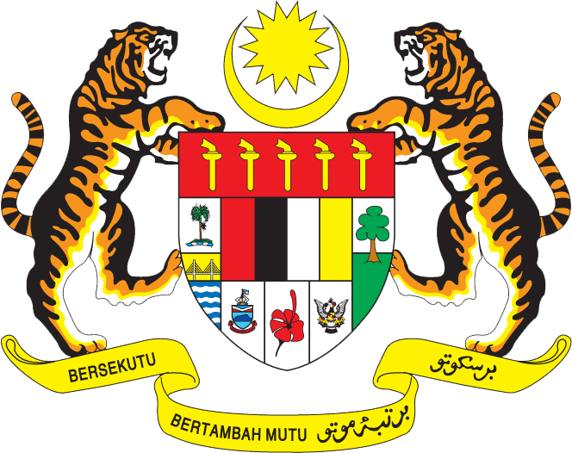

STATEMENT BY MALAYSIA
Review of Jordan
31st Session of the UPR Working Group of the Human Rights Council
8 November 2018

Thank you Mr. President.

Malaysia warmly welcomes the delegation of Jordan. We thank them for the presentation of the national report.

- Malaysia commends Jordan for the progress in advancing the rights of women and persons with disabilities, the two areas that relate to Malaysia’s recommendations during Jordan’s second UPR.

- In particular, we welcome the priorities given by Jordan to the empowerment of women. This includes eliminating barriers to their employment and participation in the public and political sphere. The policy of zero tolerance for violence against women and related efforts to strengthen legislative measures are commendable. The role of Family Reconciliation Centre in providing protection and psychological counselling services for victims of violence, and other initiatives to promote integration of persons with disabilities into the society are similar to those currently being implemented in Malaysia as well.

- While progress has been made, the challenges remain as highlighted in the report. In the spirit of constructive engagement, my delegation would like to offer the following recommendations for the consideration of Jordan:

  - Continue efforts to achieve gender equality and equal opportunities in the labour market; and
  - Develop legal mechanism to protect children and continue efforts to combat child labour.

I thank you.

GENEVA
8 November 2018

