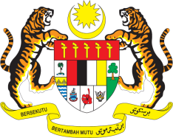

STATEMENT BY MALAYSIA
Review of Mexico
31st Session of the UPR Working Group
7 November 2018

Mr. President,

Malaysia welcomes the delegation of Mexico and thanks them for the presentation of the national report.

2. Malaysia commends Mexico’s comprehensive efforts to fight human trafficking, including those networks with links to the tourism and travel industry. Malaysia would like to urge Mexico to redouble its efforts to address poverty, extreme poverty as well as lack of access to food, health services and social security, as highlighted in its national report.

3. With the soon-to-be completion of the National Programme for Equality of Opportunities and Non-Discrimination against Women 2013-2018, we look forward to hearing from Mexico about what future steps the Government will undertake to ensure the continued success of its efforts to combat discrimination and promote equal opportunities, particularly for women.

3. In this regard, Malaysia wishes to recommend the following:

3.1. continue to address the problem of gender violence, particularly in terms of access to justice for women affected;

3.2. continue efforts to combat the scourge of human trafficking; and

3.3. to take urgent steps to further reduce the poverty level currently at 43.6%.

Thank you, Mr. President.

Geneva
7 November 2018

