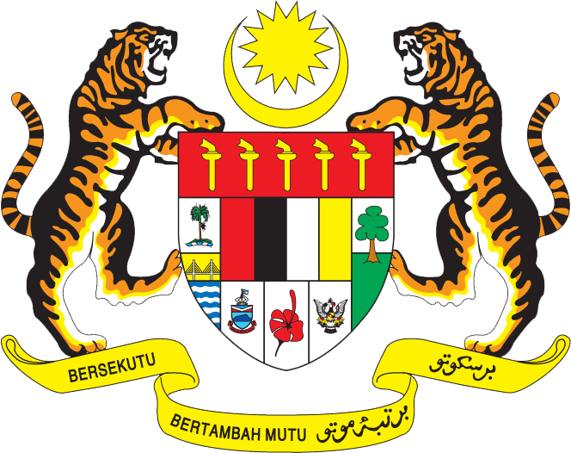

STATEMENT BY MALAYSIA
Review of China
31st Session of the UPR Working Group of the Human Rights Council
6 November 2018

Thank you Mr. President.

Malaysia warmly welcomes the delegation of the People’s Republic of China. We thank them for the presentation of China’s UPR report.

- Malaysia commends China for its many achievements in the promotion and protection of human rights. China’s economic success has certainly resulted in great improvements in the wellbeing of the many segments of its population.

- Notably, poverty eradication, advancement of women through education and employment, as well as improvements in other human rights continue to achieve commendable progress. The integration of women development issues into China’s overall national economic and social development programmes are indeed steps in the right direction to provide greater opportunities for women, narrow gender gap, and empower them.

- We further laud China’s commitment to promoting entrepreneurship and employment through proactive policies. Malaysia particularly welcomes steps undertaken to further increase women employment which now stands at 43.1 per cent of women employed nationwide.

- In the spirit of constructive engagement and cooperation, Malaysia would like to offer the following two recommendations:

  - One: Enhance cooperation and sharing of best practices with other developing countries to guarantee the rights of persons with disabilities by reducing poverty, rehabilitation and access to education; and

  - Two: Continue efforts to curtail gender discrimination.

I thank you.

GENEVA
6 November 2018

