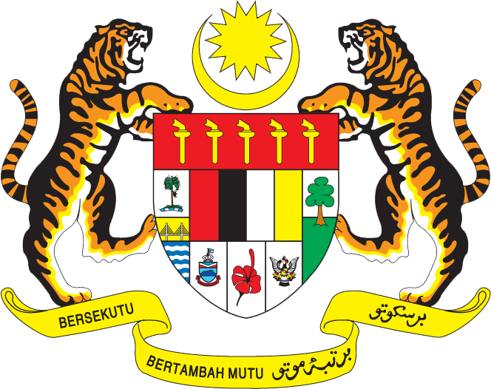

STATEMENT BY MALAYSIA
Review of Senegal
31st Session of the UPR Working Group of the Human Rights Council
5 November 2018

Thank you Mr. President.

Malaysia warmly welcomes the delegation of Senegal and thanks them for the presentation of the national report.

- Malaysia commends Senegal for its commitment in undertaking various measures to further promote and protect human rights in the country. We note positively the progress made in many areas including education, health, poverty alleviation and rights of women, children and persons with disabilities.

- We are particularly pleased to note that Senegal has effectively implemented Malaysia’s recommendation relating to the strengthening of the education system. Malaysia congratulates Senegal for the UNESCO Literacy Prize in 2016. We hope Senegal would continue its exemplary efforts to further promote literacy in the country through equitable access to education, quality teaching facilities and personnel as well as an open and transparent governance of the education system.

- We also welcome Senegal’s efforts to introduce community based programmes to reduce youth unemployment. We hope to see more measures aimed at increasing competence and participation of youth in the labour market.

- In the spirit of constructive engagement, Malaysia would like to propose the following two recommendations:

One: Allocate adequate support to further promote literacy in the country; and
Two: Continue efforts to increase employment rate particularly among the youth.

- In concluding Mr. President, my delegation would like to wish Senegal every success in its second UPR.

I thank you.

GENEVA
5 November 2018

