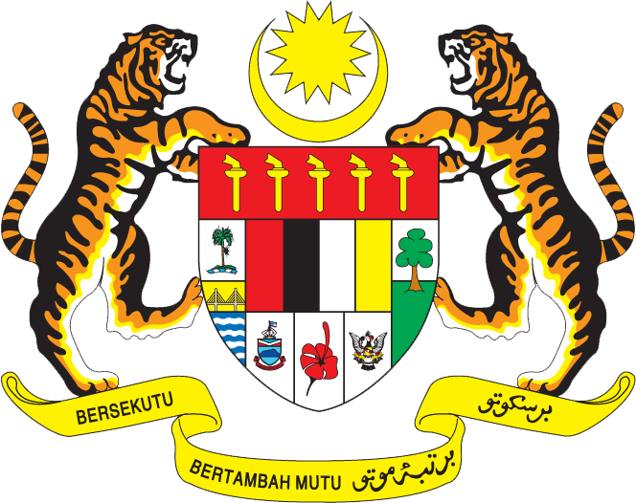

STATEMENT BY MALAYSIA
Review of Saudi Arabia
31st Session of the UPR Working Group of the Human Rights Council
5 November 2018

Thank you Mr. President.

Malaysia warmly welcomes the delegation of Saudi Arabia. We thank them for the presentation of the national report.

- Malaysia commends Saudi Arabia for undertaking many significant reforms, including by putting in place necessary legislative and institutional frameworks, to further promote and protect human rights. Various laws have been amended, while new legislations enacted since the second UPR for this purpose.

- The efforts in advancing women’s rights, such as through the establishment of Family Affairs Council are commendable. The Council which is mandated to undertake review of laws related to women and as well as develop a national strategy focusing on women, testifies the Government’s pronouncement in advancing women’s rights in the country. Malaysia hopes that the Council would be supported adequately in order for it to execute its mandate effectively.

- Malaysia also welcomes the passing of Anti-Harassment Act aimed at preventing and combating harassment and preserving the privacy, dignity and personal freedoms.

- In the spirit of constructive engagement, Malaysia would like to make the following two recommendations:

One: Continue efforts to prevent harassment related crimes; and

Two: Take further measures to increase the participation of woman in labour
market and public life.

I thank you.

GENEVA
5 November 2018

