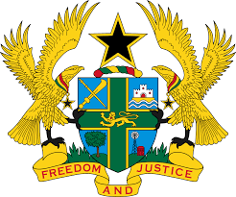
REPORT OF THE WORKING GROUP ON THE UNIVERSAL
PERIODIC REVIEW OF CHAD

STATEMENT BY GHANA DELIVERED BY H.E RAMSES JOSEPH CLELAND,
AMBASSADOR AND PERMANENT REPRESENTATIVE, TUESDAY 13TH NOVEMBER, 2018

Thank you, Mr. Vice President.

Ghana extends a warm welcome to the Chadian delegation to the 3rd UPR Cycle, and thanks them for their national report and oral update.

My delegation commends Chad for the progress made since the 2nd Cycle UPR to strengthen the promotion and protection of human rights. We welcome in particular the ratification of the Protocol to the African Charter on Human and Peoples’ Rights on the Establishment of an African Court on Human and Peoples’ Rights, the United Nations Convention against Transnational Organized Crime, and note with satisfaction the ongoing steps to ratify the Optional Protocol to the Convention against Torture, the Convention on the Rights of Persons with Disabilities, and the International Convention on the Protection of the Rights of All Migrant Workers and Members of Their Families.

Ghana further welcomes Chad’s commitment to improving access to health services and in this connection welcome the adoption of the National Health Policy, the National Strategy for Universal Health Coverage and the National Strategy on Community Health.

While welcoming the reformation of the National Human Rights Commission to ensure its full independence, and the National Strategy to Combat Gender-Based Violence among others, Ghana recommends Chad to continue implementation of the social intervention policies.

We wish the delegation of Chad a successful UPR outcome.

I thank you.

