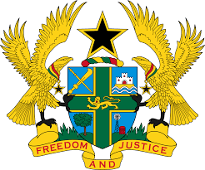
REPORT OF THE WORKING GROUP ON THE UNIVERSAL
PERIODIC REVIEW OF CONGO

STATEMENT BY GHANA DELIVERED BY H.E RAMSES JOSEPH CLELAND,
AMBASSADOR AND PERMANENT REPRESENTATIVE, WEDESDAY 14TH NOVEMBER, 2018

Thank you, Mr. President.

Ghana extends a warm welcome to the Congolese delegation to the UPR process.

We commend the Congo for prioritizing the mainstreaming of human rights into its legislative framework and development agenda, as well as for the progress made to promote and protect the rights of women, children, migrant workers and persons with disabilities.

We welcome, in this regard the ratification in 2014 of the Convention on the Rights of Persons with Disabilities and its Optional Protocol and encourage Congo to accelerate ratification of the Optional Protocol to the Convention against Torture and Other Cruel, Inhuman or Degrading Treatment or Punishment.

To further strengthen the advancement of human rights in the Congo, Ghana wishes to make the following three recommendations:

- Consider acceding to the Optional Protocol to the International Covenant on Economic, Social and Cultural Rights at the earliest convenience;

- Take steps to establish a mechanism for monitoring children’s rights with the capacity to receive, investigate and address complaints by children in a child-sensitive manner.

- Take effective measures to investigate all alleged acts of torture, and ensure that the perpetrators are brought to account.

Ghana wishes the Congo a successful UPR outcome.

I thank you.

