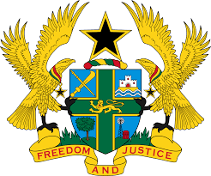

REPORT OF THE WORKING GROUP ON THE UNIVERSAL
PERIODIC REVIEW OF MEXICO

STATEMENT BY GHANA DELIVERED BY MR. ALEXANDER GRANT NTRAKWA,
DEPUTY PERMANENT REPRESENTATIVE, WEDNESDAY 7TH NOVEMBER, 2018

Thank you, Mr. President.

My delegation extends a warm welcome to the Under Secretary for Multilateral Affairs and Human Rights of Mexico and his delegation to the 3rd UPR Cycle.

Ghana commends Mexico for implementing a significant number of recommendations it accepted during the 2nd UPR Cycle to advance human rights protection and promotion in the country. We welcome in particular, the amendment of the Migration Act in 2014 and 2018 aimed at protecting the human rights of migrants, refugees and persons seeking refugee status in Mexico, as well as the National Human Rights Programme 2014–2018 to consolidate a society founded on the rule of law.

Ghana wishes to make the following two recommendations:

- Take steps to implement the General Act on the Prevention, Investigation and Punishment of Torture of 2017 especially during the first few hours of arrest;

- Continue to conduct investigations into incidence of enforced disappearances and ensure that the perpetrators are brought to justice.

My delegations wishes Mexico every success with the review process.

I thank you.

