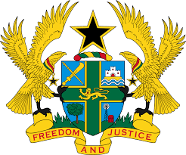

REPORT OF THE WORKING GROUP ON THE UNIVERSAL
PERIODIC REVIEW OF MAURITIUS

STATEMENT BY GHANA DELIVERED BY MR. ALEXANDER GRANT NTRAKWA,
DEPUTY PERMANENT REPRESENTATIVE, WEDNESDAY 7TH NOVEMBER, 2018

Thank you, Mr. Vice President.

Ghana thanks the Mauritius delegation for their comprehensive national report and oral update.

We commend Mauritius’ unwavering commitment to honour recommendations it accepted during the 2nd UPR Cycle. We welcome in particular the enactment of new legislations, and amendment of some existing ones, such as the Protection of Elderly Persons Act 2016 to enhance protection of the elderly, the Protection from Domestic Violence Act 2016 to protect victims of domestic violence, and the Social Integration And Empowerment Act 2016 to promote social integration and empowerment of persons living in absolute poverty.

My delegation encourages Mauritius to continue implementation of its numerous social intervention programmes to enable its people to enjoy fully their economic, political, social, and cultural rights.

Ghana further notes the efforts by the Office of the Ombudsperson to strengthen the protection of children, and recommend to the Government to provide the Office with adequate resources to enable it carry out its mandate effectively.

We wish the delegation of Mauritius every success with the review process.

I thank you.

