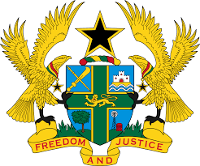
REPORT OF THE WORKING GROUP ON THE UNIVERSAL
PERIODIC REVIEW OF NIGERIA

STATEMENT BY GHANA DELIVERED BY MR. JOSEPH OWUSU-ANSAH,
COUNSELLOR, TUESDAY 6TH NOVEMBER, 2018

Thank you, Mr. Vice President.

Ghana extends a warm welcome to the Nigerian delegation to the UPR and thanks them for the oral update.

We praise the progress made by Nigeria since the second UPR Cycle in human rights protection, in particular the harmonization of three Anti-Corruption strategy documents into a single document to fight corruption. Ghana recommends Nigeria implement the National Anti-Corruption Strategy document to give impetus to the Right to Development and to safeguard the full enjoyment of civil, political, economic, social and cultural rights.

My delegation welcomes the establishment by the Nigerian Government of the National Anti-Human Trafficking Agency, as well as the incorporation of human rights dimensions into the fight against terrorism and insurgency.

We recommend speedy finalization and adoption of the National Human Rights Action Plan 2017-2022 to further strengthen Nigeria’s commitment to protecting human rights.

Ghana wishes Nigeria a successful review.

I thank you.

