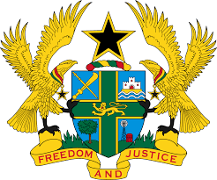

REPORT OF THE WORKING GROUP ON THE UNIVERSAL
PERIODIC REVIEW OF CHINA

STATEMENT BY GHANA DELIVERED BY MR. JOSEPH OWUSU-ANSAH,
COUNSELLOR, TUESDAY 6TH NOVEMBER, 2018

Thank you, Mr. President.

Ghana welcomes the Chinese delegation to the 3rd UPR Cycle.

We have the following two recommendations:

- Continue to strengthen the social insurance system;

- Step up efforts to further reduce poverty among the rural population.

My delegation commends China on the progress made in promoting the economic, social and cultural rights of its people. We note in particular the poverty alleviation and reduction intervention programmes that have so far lifted some 700 million Chinese citizens out of poverty, 68 million of which was achieved in the past five years.

We laud China’s social intervention initiatives targeted at women, children, persons with disabilities, the elderly and people in ethnic minority regions, and urge the government to continue to make progress in this area.

I thank you.

