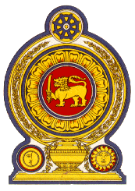

Statement by the Democratic Socialist Republic of Sri Lanka
31st Session of the Universal Periodic Review
Review of Malaysia – 08 November 2018

Mr. President,
Sri Lanka welcomes the delegation of Malaysia and appreciates the comprehensive presentation made today. We also appreciate its constructive approach to the promotion of human rights through engagement with the UN human rights mechanisms.
We take note of the significant steps taken by Malaysia to promote and protect human rights including the launch of the NHRAP in March 2018 and the Human Rights Best Practices Programme in 222 schools as well as other measures taken to enhance respect for human rights through education.
It is pertinent to note that in the 11th Malaysia Plan 2016 – 2020, women empowerment had been prioritized. Among the significant steps to empower women, we welcome the Women’s Advisory and Consultative Council established in August 2015. We also welcome the initiatives taken to increase women’s representation in decision making positions in public sector and women’s participation in labour force.
My delegation recommends that Malaysia:
- accede to the Convention on the Protection of the Rights of All Migrant Workers and Members of their Families and the Convention against Torture and other Cruel, Inhuman and Degrading Treatment or Punishment,
- further improve and advance women’s rights in particular those in disadvantaged circumstances and to ensure gender equality,
- strengthen efforts to reduce maternal mortality, through improved access to maternal healthcare services.
We wish Malaysia success in its UPR engagement and thank the delegation for its informative presentation.
Thank you.

