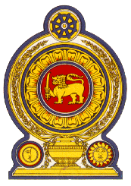
Statement by the Democratic Socialist Republic of Sri Lanka
31st Session of the Universal Periodic Review
Review of China – 06 November 2018

Mr. President,

Sri Lanka welcomes the delegation of the People’s Republic of China and expresses our appreciation for the comprehensive national report and presentation this morning. We recognize the progressive steps by the Chinese Government in promotion and protection of human rights further to the commitments undertaken at the second UPR.

We commend the achievements of the Government in reducing poverty, and note the plans to alleviate rural poverty by 2020. The construction of housing targeting the low income category is a welcome step.

We also note the adoption of policies and measures to strengthen the educational resources in remote, rural and ethnic minority areas and that in 2017, the enrolment of primary school children stood at 99.1%. The progress achieved in implementation of policies and programmes furthering the right to health is similarly commendable.

My delegation recommends that the People’s Republic of China:
- accede to the International Convention on the Protection of the Rights of All Migrant Workers and Members of their Families,

- further improve access to education for children, especially those living in rural areas and children of migrant workers,

- take further steps to consolidate programmes and actions aimed at improving public healthcare, including further reducing maternal and infant mortality.

Finally, we wish the People’s Republic of China success in its UPR engagement.

Thank you.

