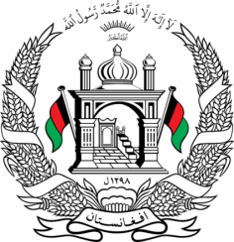
Permanent Mission of Islamic Republic of Afghanistan
31th Session of UPR Working Group
Statement at the 3th UPR of Malta
(November 14, 2018)
Thank you, Mr. President!
Afghanistan welcomes the distinguished delegation of Malta and thanks it for the presentation of its third national report.
We commend Malta's efforts in combating human trafficking through various initiatives including development of victim assistance services, training of government officials, public awareness raising, enactment of a new Victims of Crime Act and establishment of the National Referral Mechanism.
With the spirit of constructive dialogue, we would like to make the following recommendations:
- Continue implementation of the framework for the education strategy for 2014–2024 in order to reduce the gaps in educational outcomes between boys and girls,
- Strengthen its efforts to eradicate stereotypes and discrimination against migrants, inter alia, by conducting public awareness-raising campaigns to promote tolerance and respect for diversity.
Afghanistan wishes the distinguished delegation of Malta every success in the UPR review process.
I thank you, Mr. President!

