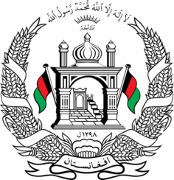
Permanent Mission of Islamic Republic of Afghanistan
31^{h} Session of UPR Working Group
Statement at the 3th UPR of Congo
(November 14, 2018)
Thank you, Mr. President!
Afghanistan welcomes the distinguished delegation of the Republic of the Congo and thanks for presentation of its national report.
It is encouraging that Congo since its last UPR, ratified several Core international human rights instruments, inter alia, International Convention on the Protection of the Rights of All Migrant Workers and Members of Their Families, Convention on the Rights of Persons with Disabilities and the Optional Protocol thereto, as well as OPCAT. Furthermore, we congratulate Congo for approving National Action Plan to implement the UN Security Council Resolution 1325 on Women, Peace and Security.
With the spirit of cooperation, we would like to make the following recommendations:
- Continue the reform of its national legal framework for ensuring its compliance with the provisions of the international and regional human rights instruments;
- Strengthen its efforts for ensuring access to inclusive education for all children, particularly for vulnerable groups including indigenous and poor children, girls and children with disabilities,
We wish the delegation of the Republic of Congo every success in the UPR process.
I thank you, Mr. President!

