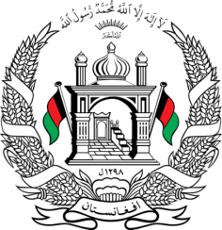
Permanent Mission of Islamic Republic of Afghanistan
31^{h} Session of UPR Working Group
Statement at the 3th UPR of Malaysia
(November 8, 2018)
Thank you, Mr. President!
Afghanistan welcomes the distinguished delegation of Malaysia and thanks for presentation of its national report.
We commend the efforts have been made by Malaysia regarding women’s empowerment in decision making positions in the public sector, economic empowerment programs for vulnerable women and declaring 2018 as the Year of Women Empowerment.
Furthermore, we commend Malaysia for measures taken on human rights education programs and continued contribution to promote educational and reconciliatory dialogue as part of its efforts for enhancing the values of moderation, tolerance and mutual respect between and among societies, cultures and religions.
We would like to recommend Malaysia to:
- Consider the accession to the 1951 UN Convention relating to the Status of Refugees;
- Intensify its efforts to ensure access to primary and secondary education to asylum seekers and refugees and to offer them equal education opportunity.
We wish Malaysia every success in the UPR process.
Thank you, Mr. President!

