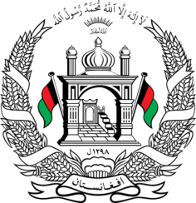
Permanent Mission of Islamic Republic of Afghanistan
31th Session of UPR Working Group
Statement at the 3th UPR of China
(November 6, 2018)
Thank you, Mr. President!
Afghanistan welcomes the distinguished delegation of China and commends the contribution of the People’s Republic of China with regards to the UPR process.
My delegation appreciates the continued efforts by China for poverty alleviation, generating employment opportunities, promoting right to education in urban and rural areas and reduction of maternal and infant mortality rates in the last years. Furthermore, we commend the China's contribution in the regional development initiatives.
Mr. President;
With the spirit of constructive dialogue, Afghanistan would like to recommend to the distinguished delegation of China to:
- Further ensure the advancement of the human rights of all minority groups in the country,
- Ratify the Convention against Discrimination in Education and maintain its efforts to ensure access to quality education for disadvantaged children in poor and remote areas and among ethnic minority groups and children of migrants.
Afghanistan wishes the distinguished delegation of China every success in the UPR review process.
Thank you, Mr. President!

