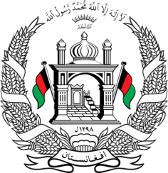
Permanent Mission of Islamic Republic of Afghanistan
31th Session of the UPR Working Group
Statement at the 3th UPR of Senegal
November 5, 2018
Thank you, Mr. President!
Afghanistan welcomes the distinguished delegation of Senegal and thanks it for the presentation of its third national report.
My delegation commends Senegal for undertaking the referendum based constitutional reform in 2016 and for enacting various legislative measures including the Law on Nationality.
Mr. President;
While appreciating Senegal’s human rights achievements, we wish to make the following recommendations:
- Adopt the draft Children's Code while ensuring its compliance with the provisions of the international human rights instruments and undertake appropriate measures including seeking technical assistance from the international community for its effective implementation.
- Continue its efforts to ensure the right to quality and inclusive education with a focus on girls' access to education and maintain its already undertaken steps for modernizing the religious schools.
We wish Senegal every success in the UPR review process.
I thank you, Mr. President!

