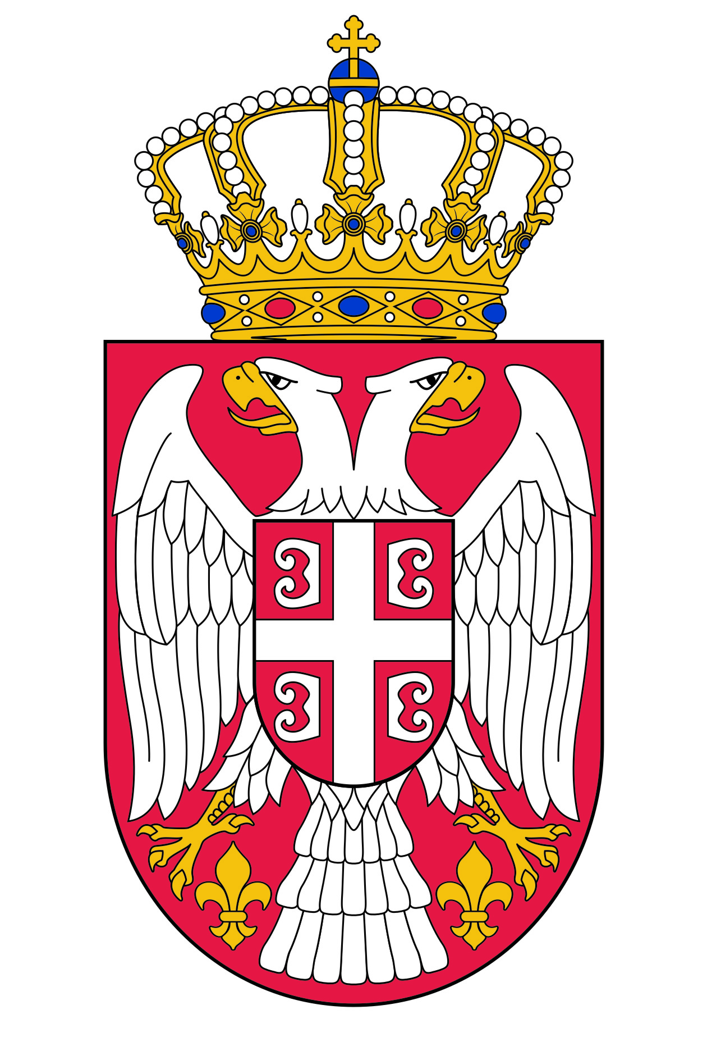
PERMANENT MISSION MISSION PERMANENTE
OF THE REPUBLIC OF SERBIA DE LA RÉPUBLIQUE DE SERBIE
TO THE UNITED NATIONS AUPRÈS DES NATIONS UNIES
AND OTHER INTERNATIONAL ET DES AUTRES ORGANISATIONS
ORGANIZATIONS I NTERNATIONALES

Working Group for UPR
Interactive Dialogue on Report of Nigeria
November 2018

Mr. President,

The Republic of Serbia warmly welcomes the delegation of Nigeria and thanks for the presentation of its national report.

We commend all the activities and efforts that have been invested by the authorities of Nigeria aimed at the implementation of the recommendations from the previous UPR cycle.

Serbia particularly welcomes the constitution of the national technical committee on the establishment and management of a database of missing persons.

We, also, commend the developing of a social and economic master plan named Economic Recovery and Growth Plan covering the period 2017–2020.

We recommend Nigeria to take measures by which women and girls with disabilities facing physical and economic barriers in various fields gain, with no restrictions, access to health care, education and employment.

We wish Nigeria every success in implementing the recommendations of this cycle.

Ch. Thury 5, CH-1206 – Genève, tel. +41 22 839 33 44 fax. +41 22 839 33 59, e-mail: serbian.mission@bluewin.ch

