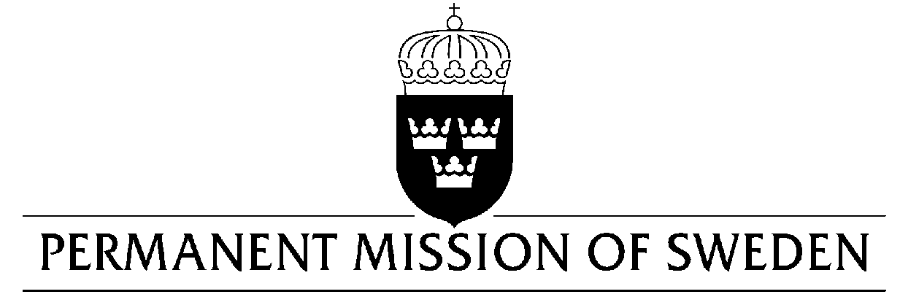
UN Human Rights Council

UPR 31st session

Statement by Sweden in the interactive dialogue on Chad

Delivered by Minister-Counsellor Karin Bolin
Geneva, 13 November 2018 (speaking time 1,25 sec, speaker no. 19)

Mr. President,
Sweden wishes to warmly welcome the delegation of Chad. Sweden welcomes some positive developments, including the establishment of a requirement for gender parity in elections and appointments to office. Sweden also acknowledges that the new Criminal Code abolished the death penalty for ordinary crimes, and that the Government is in support of abolishing the death penalty completely. However, Sweden would like to encourage further efforts to stop gender-based violence as well as to guarantee the freedom of expression.

Sweden would like to make the following recommendations:

- To implement further measures to prevent violence against women, including female genital mutilation and other harmful practices and to combat impunity in this regard specifically by ensuring compliance with existing legislation.

- To ratify the Optional Protocol to CEDAW and the Protocol to the African Charter on Human and People’s Rights on the Rights of Women in Africa.

- To respect freedom of the press and the right to freedom of opinion and expression in accordance with domestic law, the International Covenant on Civil and Political Rights and other international standards to ensure that journalists, media workers and human right defenders are able to freely exercise their rights to freedom of expression, without fear of reprisals, arrest, detention, intimidation, threat or harassment.

Sweden wishes Chad all success in the current review.

I thank you Mr. President

