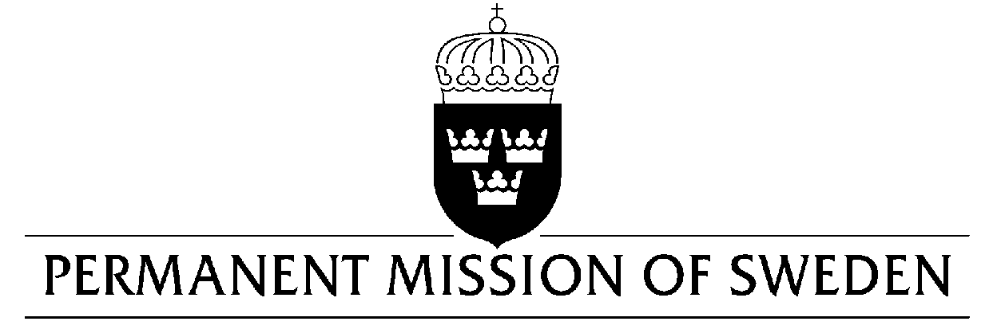
UN Human Rights Council

UPR 31st session

Statement by Sweden in the interactive dialogue on Senegal

Delivered by Minister-Counsellor Karin Bolin
Geneva, 5 November 2018 (speaking time 1.05, speaker no. 103)

Mr. Vice-President,
Sweden wishes to welcome the delegation of Senegal and extends its thanks for the report and presentation. Sweden welcomes some positive developments regarding the protection of children from exploitation but remains concerned over many aspects of children’s rights and situation.

Sweden would like to make the following recommendations:

- To enforce domestic laws which prohibit the use of children for begging, child trafficking and child abuse.

- To ensure child sensitive prevention and reparations protection services.

- To revise the Criminal Code in line with regional and international law and standards, including by criminalizing marital rape and decriminalizing abortion, and to implement relevant existing laws.

- To respect freedom of opinion and expression in accordance with international law as well as domestic law.

- To ensure that journalists and media workers can freely exercise their rights to freedom of expression without fear of reprisals, detention, intimidation, threats or harassment.

Sweden wishes the Government of Senegal a successful review.
I thank you Mr. Vice President

