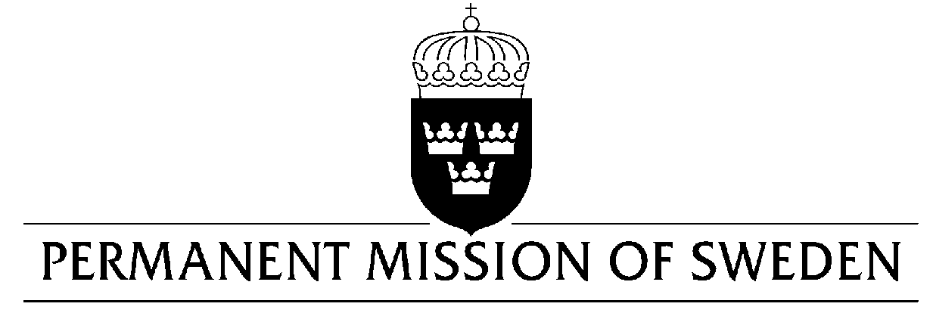
UN Human Rights Council

UPR 31st session

Statement by Sweden in the interactive dialogue on the Kingdom of Saudi Arabia

Delivered by Ambassador Mikael Anzén
Geneva, 5 November 2018 (speaking time 1.15, speaker no. 101)

Mr. President,
Sweden wishes to warmly welcome the delegation of the Kingdom of Saudi Arabia and extends its thanks for the report and presentation. Sweden remains seriously concerned about a number of human rights issues in the Kingdom of Saudi Arabia, including the case of Jamal Khashoggi, while noting that some progress has been made in improving the situation for women, including advancing women’s participation in the labour market.

Sweden would like to make the following recommendations:

- to impose a moratorium on the use of capital punishment with a view to abolish it.

- to take urgent action to improve the protection of human rights defenders.

- to abolish the male guardianship.

- to take urgent action towards media freedom in the country, including by reviewing the 2007 Anti-Cyber Crime Law.

Sweden wishes the Kingdom of Saudi Arabia all success in the current review and in implementing the recommendations.

I thank you Mr. President

