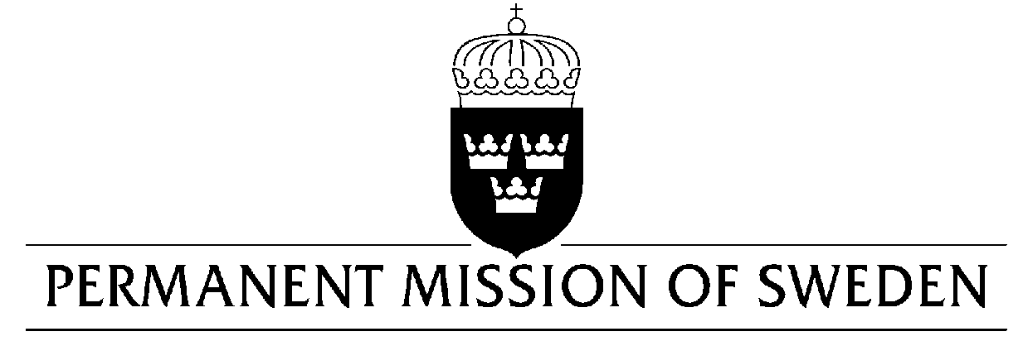
UN Human Rights Council

UPR 31st session

Statement by Sweden in the interactive dialogue on Nigeria

Delivered by Minister-Counsellor Karin Bolin
Geneva, 6 November 2018 (speaking time 1 min, speaker no. 108)

Mr. Vice-President,
Sweden warmly welcomes the delegation of Nigeria. Sweden welcomes the continued effort of Nigeria to improve the human rights situation, especially in fighting corruption. However, we encourage further efforts to ensure respect, protection and fulfilment of human rights, including for persons in vulnerable situations.

Sweden would like to make the following recommendations:

- To take further measures to fulfil its obligations under the CEDAW Convention and Security Council Resolution 1325 to protect women from sexual violence in IDP-camps and that allegations of misconduct are investigated and brought to justice. And to, in this context, establish an oversight mechanism for security forces, that meet with international human rights standards.

- To introduce a moratorium on death penalty with a view to abolish it.

- To ensure the respect, protection and fulfilment of human rights for all persons, without distinction of any kind.

Sweden wishes the Government of Nigeria all success in the current review.

I thank you Mr. President

