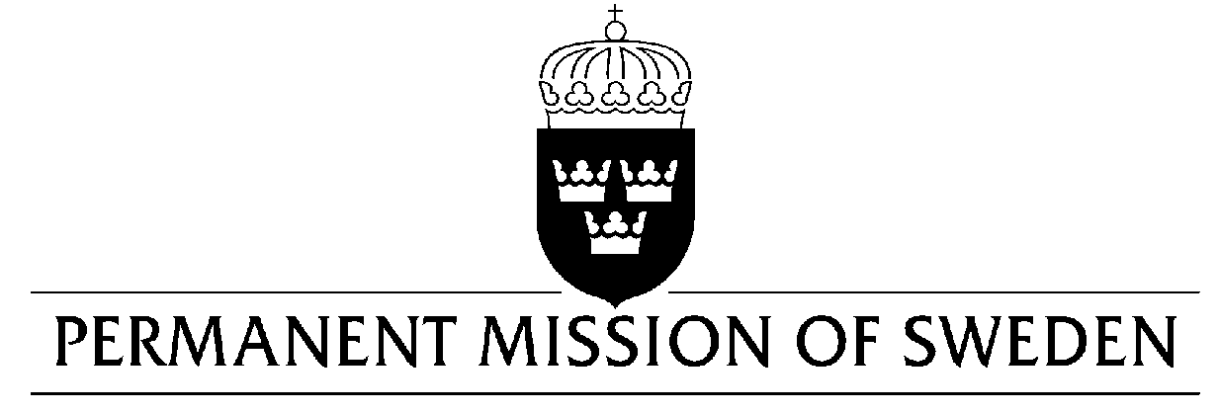
UN Human Rights Council

UPR 31st session

Statement by Sweden in the interactive dialogue on Mexico

Delivered by Minister-Counsellor Karin Bolin
Geneva, 7 November 2018 (speaking time 1.10, speaker no. 99)

Mr. President,
Sweden wishes to warmly welcome the delegation of Mexico. Sweden congratulates Mexico on its’ strong commitment to international policy development and ratification of many human rights treaties. Yet, high levels of violence and serious violations and abuses of human rights continue and need to be addressed.

Sweden would like to make the following recommendations:

- To strengthen the mechanism for protection of human rights defenders and the safety of journalists, in particular women, and to ensure that it has adequate resources and powers to carry out its work also at state and municipal levels.

- To ensure that intimidation or harassment, including against journalists and human rights defenders, are investigated promptly, impartially and exhaustively, guaranteeing that perpetrators are held accountable and victims are granted effective remedies.

- To effectively protect, promote and guarantee the safety and human rights of migrants and refugees, including the right to seek asylum, especially those who are in transit within the national territory and around the Southern border. Special attention needs to be given to women and children.

Sweden wishes Mexico all success in the current review.

I thank you Mr. President

