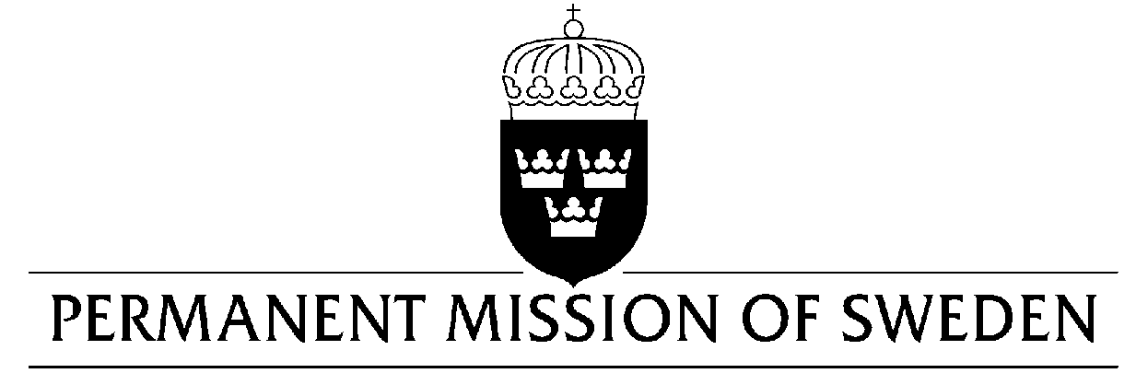
UN Human Rights Council

UPR 31st session

Statement by Sweden in the interactive dialogue on Malta

Delivered by Minister-Counsellor Karin Bolin
Geneva, 14 November 2018 (speaking time 1.40, speaker no. 20)

Mr. President,
Sweden wishes to warmly welcome the delegation of Malta. Sweden congratulates Malta for the adoption of the LGBTI-law in 2015 as well as positive steps in the field of SRHR such at the Malta Medicines Authorities approval of the sale of emergency contraception pills without prescription in 2016. The brutal murder of journalist Daphne Caruana Galizia in 2017 showed the risks associated with investigating corruption, money laundering and organized crime. Sweden welcomes the steps taken by Malta to improve the process of handling applications of asylum as well as the strategy to strengthen the integration of migrants. We also note that Malta has fulfilled its responsibility in the EU Relocation and Resettlement programs.

Sweden would like to make the following recommendations:

- To take steps to increase the promotion and protection of women’s full enjoyment of their human rights, especially to be able to determine over their own bodies and reproduction, including the legalization of abortion.

- To strengthen its anti-corruption institutions, including the enforcement of anti-money laundering regulations.

- To improve conditions in detention centres, including to seek alternatives to detention in line with international law, including human right and refugee law, as well as existing European legislation.

- To sign and ratify the UN Convention on statelessness

Sweden wishes Malta all success in the current review.

I thank you Mr. President

