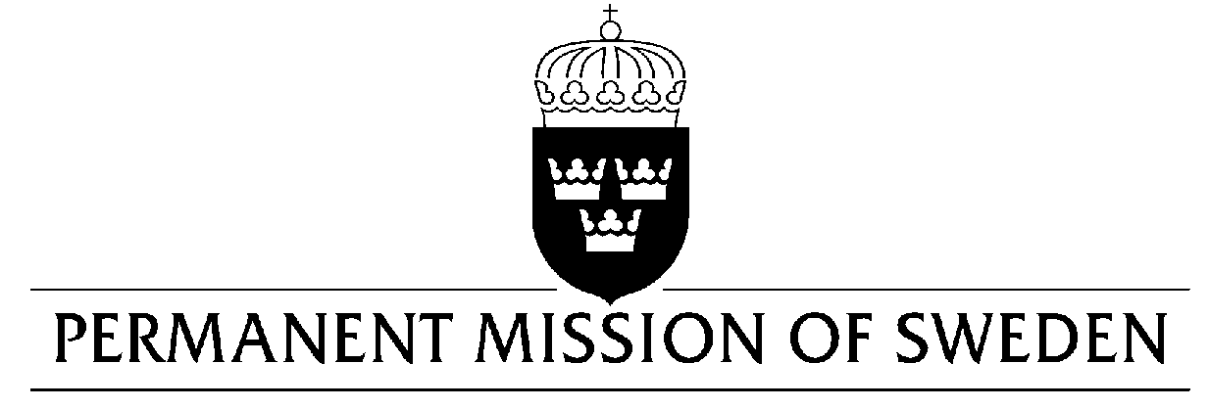
UN Human Rights Council

UPR 31st session

Statement by Sweden in the interactive dialogue on Malaysia

Delivered by Minister-Counsellor Karin Bolin
Geneva, 8 November 2018 (speaking time 1.05, speaker no. 8)

Mr. President,
Sweden wishes to warmly welcome the delegation of Malaysia. Sweden congratulates Malaysia for its ambitious Human Rights Agenda and encourages and emphasizes the need for continued efforts.

Sweden would like to make the following recommendations:

- To approve and implement legislation for the complete abolishment of the death penalty.

- To abolish all forms of corporal punishment in the legal system and withdraw its reservations to the Convention on the Rights of the Child, in particular article 37 on torture and deprivation of liberty.

- To eliminate all forms of discrimination against women and girls and withdraw all remaining reservations to article 9 and 16 of the Convention on the Elimination of All Forms of Discrimination of Women.

Sweden wishes Malaysia all success in the current review.

I thank you Mr. President

