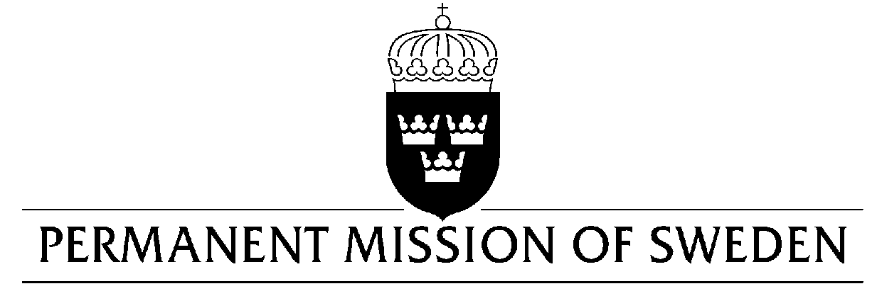
UN Human Rights Council

UPR 31st session

Statement by Sweden in the interactive dialogue on China

Delivered by Ambassador Mikael Anzén
Geneva, 6 November 2018 (speaking time 45 sec, speaker no.134)

Mr. President, Sweden welcomes the delegation of China and would like to make the following recommendations:
- To take urgent steps to respect the rights of persons belonging to ethnic minorities including the right to peaceful assembly, to manifest religion and culture – in particular in Xinjiang and Tibet.

- To remove restrictions on freedom of expression and press – including on the internet – that are not in accordance with international law.

- To ensure full enjoyment of human rights for women, girls and individuals of all sexual orientations and gender identities – by implementing the anti-domestic violence law and clearly defining its coverage.

- Respect the rights of all detainees under relevant human rights instruments and the Vienna Convention, including due process.

Sweden wishes the Government of China all success in the current review. I thank you Mr. President

