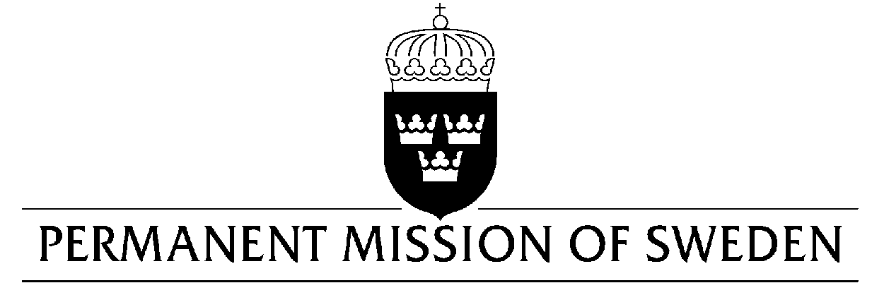
UN Human Rights Council

UPR 31st session

Statement by Sweden in the interactive dialogue on the Kingdom of Jordan

Delivered by Minister-Counsellor Karin Bolin
Geneva, 6 November 2018 (speaking time 1.15, speaker no. 86)

Mr. Vice-President,
Sweden wishes to warmly welcome the delegation of Jordan. Sweden welcomes some positive developments in media legislation, but remains concerned about the ambiguity of definitions and the risk of too broad interpretations. Jordan aspires to achieve gender-neutrality in its legislation and shows a remarkable level of gender equality in the health and education sectors. However, many challenges remain for the advancement of gender equality.

Sweden would like to make the following recommendations:

- To revise and specify the definition of incitement to hatred in the amended 2018 cybercrimes law.

- To form a committee of independent experts to consider amendments to media-related legislation and institutions.

- To further advance the amendments of the Public Gathering Law by creating an independent bureau to receive complaints regarding meetings and gatherings that have been shut down without explanation.

- To amend Article 72 of the Labour Law to make it more comprehensive in order to allow for women to participate in the workforce, and encourage childcare to be a shared responsibility between both parents.

Sweden wishes Jordan all success in the current review.

I thank you Mr. President

