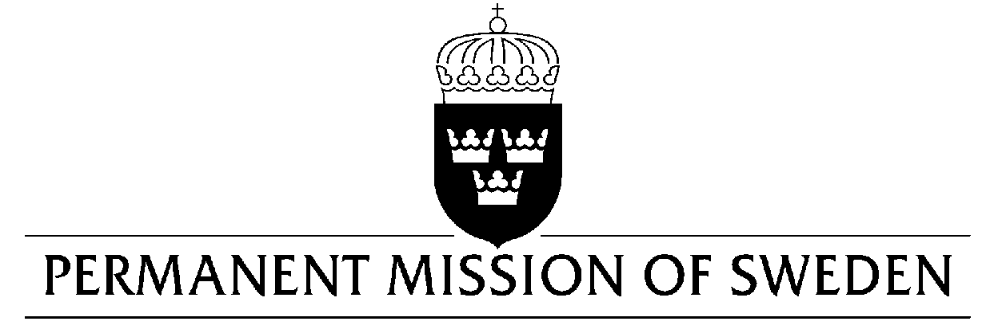
UN Human Rights Council

UPR 31st session

Statement by Sweden in the interactive dialogue on the Central African Republic

Delivered by Minister-Counsellor Karin Bolin
Geneva, 9 November 2018 (speaking time 1.20, speaker no.52)

Mr. Vice-President,
Sweden wishes to warmly welcome the delegation of the Central African Republic.
Sweden congratulates the Central African Republic on the recent appointment of the Special Prosecutor and several magistrates to its Special Criminal Court. We encourage further steps to secure additional financial support and a stronger political commitment to the Special Court, as well as the broader justice sector.

Sweden would like to make the following recommendations:

- To give higher priority to the justice sector, including the Special Criminal Court, through an increased allocation of state resources.

- To organize mobile court hearings in remote areas where court buildings have been destroyed.

- To develop and adopt legislation that obligates national courts to ensure the safety and the right to privacy for victims and witnesses, and to establish an independent protection program to ensure its implementation.

- To take special measures to monitor, identify, and report serious human rights violations including sexual and gender based violence including through investigative missions to the western parts of CAR, to prevent and ensure accountability for crimes committed, as well as to exclude these crimes from impunity and amnesty processes.

Sweden wishes the Central African Republic all success in the current review.

I thank you Mr. Vice- President

