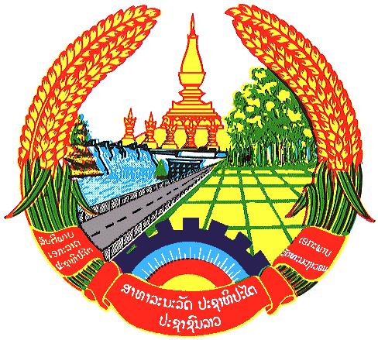

Statement by H.E. Kham-Inh KHITCHADETH, Ambassador and Permanent Representative of the Lao PDR
At the 31th Session of UPR Working Group
Geneva, 5-16 November 2018

Review of Malaysia: 8 November 2018, at 14:30 - 18:00 hours

Mr. President,
Lao PDR welcomes the delegation of the Malaysia and thanks for its comprehensive report on human rights development and would like to congratulates Malaysia for the progress made on promotion and protection on human rights, including the Government’s Poverty Eradication Programme, establishment of Child Care and Child Protection Unit at all district social welfare Offices and the Women’s Advisory and Consultative Council.

Lao PDR makes three recommendations:

- First, strengthen policies and measures for the well-being of the indigenous peoples in Malaysia to uplift their economic and social status, and benefit from the country’s economic development;
- Second, continues efforts in promoting women’s capacity to participate in all aspects of life as well as nation’s development; and
- Third, shares its experiences and lesson learned with ASEAN countries on poverty eradication through bilateral and multilateral mechanisms.

We wish Malaysia every success in its 3rd cycle of UPR.

I thank you, Mr. President.

