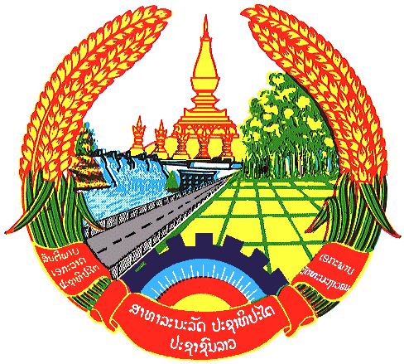

Statement by H.E. Kham-Inh KHITCHADETH, Ambassador and Permanent Representative of the Lao PDR
At the 31th Session of UPR Working Group
Geneva, 5-16 November 2018

Review of China: 6 November 2018, at 9:00 - 12:30 hours

Mr. President,
Laos wishes to congratulate the People’s Republic of China for the informative and comprehensive report on the progress of human rights development with Chinese characteristics.

Laos has three recommendations:

First, continue to communicate with other developing countries on the experience of the state governance, including promoting and protecting human rights;

Second, continue to guarantee the rights of ethnic minorities to participate in the management of state and social affairs on an equal footing according to Law;

Third, continue to carry out the new development concept and build a modern economic system.

In this connection, we also commend China’s remarkable achievements in socio-economic development as well as the great efforts to achieve the socialist modernisation by 2035 and the construction of a great modern socialist country by 2050.

I thank you, Mr. President.

