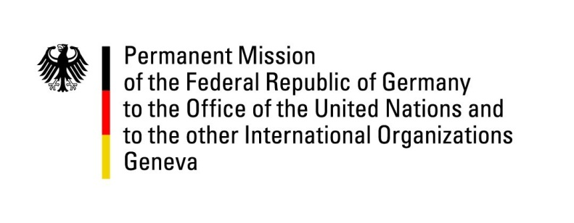

United Nations Human Rights Council

31st Session of the UPR Working Group

Geneva, 14 November 2018

German recommendations to

Malta

Mr. President,
Germany welcomes the delegation of Malta. Germany commends Malta for the introduction of same sex marriage in July 2017.
Germany is still concerned about the fact that there is no explicit prohibition on the recruitment of children under the age of 15 into the Armed Forces in Malta.
Germany would like to offer the following recommendations:
- To revise the legislation on Public Service Media (PSM) including appointment procedures, in order to establish safeguards from political interference;
- To revise the legislation on the financing of political parties as well as on the investigative powers of the Electoral Commission, in order to provide transparency with regard to the political parties’ donations and effective public control over the fulfillment of prerequisites for such donations.
We thank you, Mr. President.

