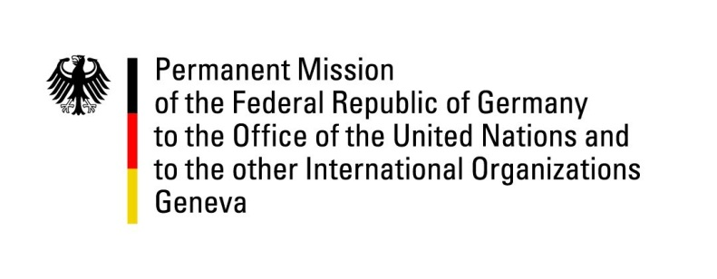

United Nations Human Rights Council

31st Session of the UPR Working Group

Geneva, 14 November 2018

German questions and recommendations to

The Republic of Congo

Thank you, Mr. President,
Germany welcomes the delegation of the Congo. We commend Congo for the abolishment of the death penalty in its constitution in 2015 and for the judicial sector dialogue held between the European Union and Congo in April 2018 and, which, we hope, will be followed by further sector and political dialogues.
Germany would like to offer the following recommendations to Congo:

- Investigate fully the death of 13 juveniles in a police station in Brazzaville in July 2018 and prosecute the responsible persons;

- Ensure that the police, the army or the General Direction of Territory Surveillance and the gendarmerie refrain from imprisoning detainees longer than the 72-hour limit stipulated in Article 48 of the Criminal Code of Procedure and grant human rights monitors access to detention centers;

- Include a concrete definition of torture according to the Convention against Torture in the Criminal Code and take effective measures to ensure the prosecution of all perpetrators of any forms of ill treatment;

- Ratify the Second Optional Protocol to the International Covenant on Civil and Political Rights consequently to the abolishment of the death penalty in the constitution;

- Reinforce the equality of men and women by modernizing the divorce law and penalizing rape in marriages.

Thank you, Mr. President.

