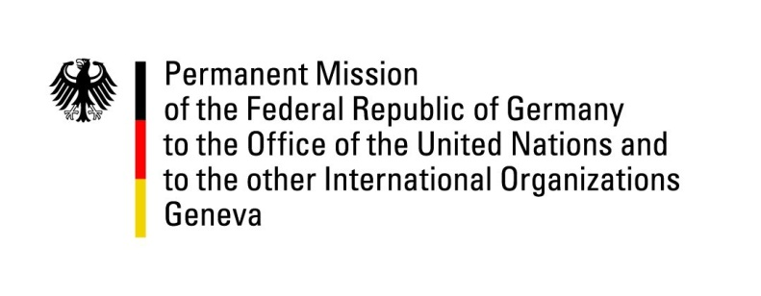

United Nations Human Rights Council

31st Session of the UPR Working Group

Geneva, 13 November 2018

German questions and recommendations to

The Republic of Chad

Mr. President,
Germany commends Chad for efforts made with regard to the revised penal code that came into effect in May 2017, which is prohibiting child marriages and female genital mutilation, and penalizing crimes such as trafficking in human beings.
Germany remains concerned about other aspects of the human rights situation in Chad. Especially with regard to the effective improvement of the human rights situation of children, more needs to be done.

Germany would like to offer the following recommendations:
- Strengthen the position of children and women by adopting the ‘code de la famille’ and by the effective implementation of the Convention on the Rights of the Child and the Optional Protocols thereto;

- Abolish the death penalty for all crimes, including terrorism related crimes, and ratify the Second Optional Protocol to the International Covenant on Civil and Political Rights on the abolition of the death penalty;

- Ensure freedom of expression, association and peaceful assembly for all citizens by changing the official regulations in order to meet international human rights law and standards and by effectively addressing threats, attacks, harassment and intimidation against human rights defenders and journalists;

- Ensure effective implementation of the law against female genital mutilation in every region and to investigate any form of non-compliance.

GERMAN ADVANCE QUESTIONS TO CHAD:
- The revised penal code from 2017 still criminalizes homosexuality. What measures are taken to improve the situation of LGBTI persons in Chad?
- The conditions in prisons are not in conformity with human rights and international standards. What steps are taken to improve the detention conditions and to guarantee that human rights of detainees are respected?
- In how far were recent death sentences from August 2018 in line with the penal code, which abolishes the death sentence for all crimes except terrorist acts?
- With regard to the effective implementation of the revised penal code, which measures did the government already take to address the issue of impunity and what are the next steps?

