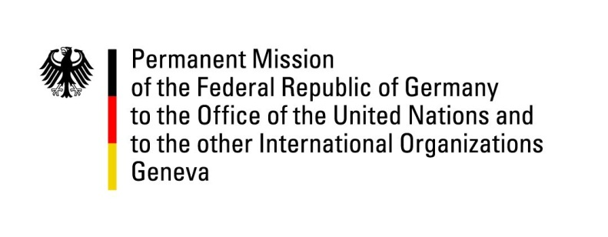

United Nations Human Rights Council

31st Session of the UPR Working Group

Geneva, 12 November 2018

Recommendations to
Belize

Thank you, Mr. President,
Germany welcomes the delegation of Belize.
Germany appreciates the ratification of the International Covenant on Economic and Social Rights, the Convention for the Protection of all Persons from Enforced Disappearance and the ratification of the Optional Protocol of the Convention against Torture.
We also welcome the decision for a referendum to decide whether to take a dispute over territory with Guatemala to the International Court of Justice for final settlement.
Germany, however, continues to be concerned regarding a number of human rights issues, leading to the following recommendations:
Germany recommends:
- Secure equal human rights for LGBTI persons by adding sexual orientation and gender identity to the anti-discrimination legislation, in order to protect LGBTI persons against discrimination and violence.
- Fully implement the National Gender-Based Violence Plan through concrete measures nationwide, to decrease domestic violence and discrimination against women.
- Establish a National Human Rights Institution (NHRI) in line with the Paris Principles.
Thank you, Mr. President.

