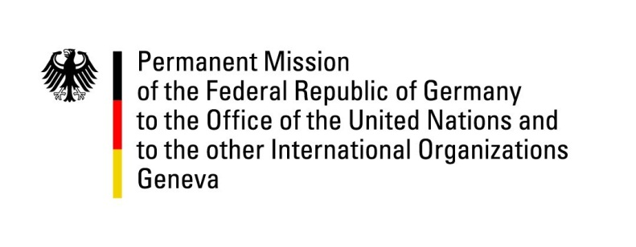

United Nations Human Rights Council

31st Session of the UPR Working Group

Geneva, 12 November 2018

German questions and recommendations to

Monaco

Mr. President,
Germany welcomes the delegation of Monaco and commends Monaco for the ratification of the Council of Europe Convention on preventing and combating violence against women and domestic violence (Istanbul Convention) and of the United Nations Convention on the Rights of Persons with Disabilities.
Germany would like to offer the following recommendations:
- To join the International Labour Organization and the respective conventions of the ILO;
- To ratify the Rome Statute on the International Criminal Court and align its national legislation with all obligations under the Rome Statute.
We thank you, Mr. President.

Questions submitted in advance:
- Monaco did not yet join the International Labor Organization (ILO). What measures are taken to accelerate the accession of Monaco to the ILO and the respective conventions?

