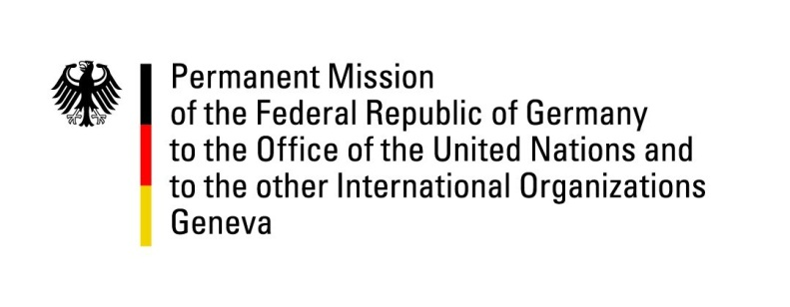

United Nations Human Rights Council

31st Session of the UPR Working Group

Geneva, 9 November 2018

Recommendations and advance questions to
Central African Republic
Mr. President,
Germany welcomes the delegation of the Central African Republic. We acknowledge the steps taken to protect human rights and welcome the fact that national penal courts started prosecuting human rights abuses. We also commend the progress made regarding the establishment of institutions for the protection of vulnerable groups.
Germany remains concerned about the fact that the death penalty has not been abolished, and about the general security situation. The protection of the civilian population against armed groups and provision of a safe environment for humanitarian aid workers must be a priority. We urge the government to condemn any attacks on humanitarian actors and reinforce efforts to prevent such attacks.
Germany offers the following recommendations:
- Implement article 151 of the Penal Code and prosecute all acts of human trafficking;
- Improve the human rights status of minority groups and de-criminalize homosexuality;
- Strengthen the protection of the rights of the child through state enforcement and monitoring of the existing legislative framework regarding child labor;
- Abolish the death penalty still contained in the Penal Code of 2010 and accede to the Second Optional Protocol to the ICCPR.
We thank you, Mr. President.

