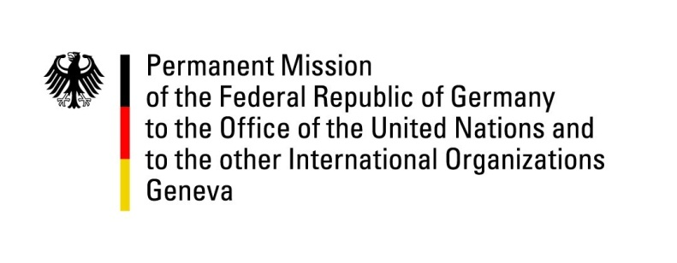

United Nations Human Rights Council

31st Session of the UPR Working Group

Geneva, 08 November 2018

Recommendations and advance questions to
Malaysia

Thank you, Mr. President,

Germany welcomes the delegation of Malaysia. We commend the Malaysian government for the decision to abolish the death penalty. We also commend the Malaysian Prime Minister for issuing a directive to all state governments in Malaysia to set the legal minimum marriage age to 18 years.
Germany remains concerned about the human rights situation of LGBTI persons in Malaysia.

Germany recommends:

1) Swiftly pass all necessary legislation to abolish the death penalty for all criminal offences.
2) Repeal all legislation that discriminates on the basis of sexual orientation or gender identity to guarantee that LGBTI persons can enjoy all human rights without facing discrimination with regard to work, health, educational, housing and other policy.
3) Review all relevant legislation with a view to setting the minimum legal age for marriage for all persons at 18 years of age.
4) Abolish corporal punishment in the legal system.

Thank you, Mr. President.
GERMAN ADVANCED QUESTIONS TO MALAYSIA:

- Which UN conventions on human rights does Malaysia plan to ratify in this legislative period?
- Which measures will Malaysia adopt to protect the human rights of LGBTI persons?

