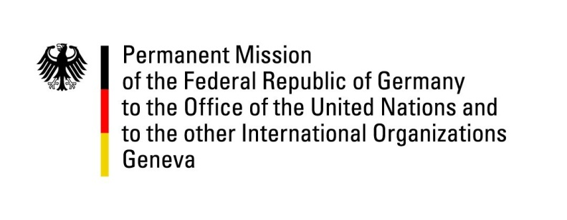

United Nations Human Rights Council

31st Session of the UPR Working Group

Geneva, 8 November 2018

Recommendations and advance questions to
Jordan

Mr. President,
Germany welcomes the delegation of Jordan to the UPR and commends Jordan for the creation of the Comprehensive National Plan for Human Rights. We further appreciate the reform of Articles 308 and 98 of the Penal Code, the opening of the first shelter for women victims of violence and the passing of the Right of Disabled Persons Law in line with the Convention on the Rights of Persons with Disabilities.
We remain concerned about ongoing reports of ill-treatment and torture in prisons, intimidations of civil society and NGOs and restrictions on the freedom of the media and expression, leading to the following recommendations:
1) Withdraw the reservation to Art. 9 para. 2 of CEDAW and amend the Nationality Law so that Jordanian women pass on their citizenship to their children on an equal basis to Jordanian men, and end the discrimination of all non-citizen children of Jordanian women.
2) Guarantee that every person that is arrested has access to legal representation and legal aid, from the moment of arrest, regardless of the alleged crime, to promptly implement all relevant regulations in this regard, and to ensure civilian prosecutors investigate all allegations of abuses in detention.
3) Amend the Criminal Procedures Law to guarantee that a detained person is medically assessed before admission to a detention center.
4) Facilitate the creation and operation of civil society organizations by amending the Law of Societies in accordance with ICCPR-requirements, by limiting state interference, in particular restrictions to funding, and by ensuring that any such interference is exercised in an accountable and transparent way.
Thank you, Mr. President
GERMAN ADVANCE QUESTIONS TO JORDAN
- Building on the positive legal amendments in the area of prosecuting torture and providing legal aid that have already been passed, which further steps does Jordan plan to take to redefine torture in line with international standards, to prosecute perpetrators of torture in civil courts, and to provide legal aid to every person who is arrested, as Jordan agreed in both previous UPR sessions and pledged to do in its Comprehensive National Plan for Human Rights (CNPHR)?
- Which steps does Jordan plan to take in order to increase the independence of the judiciary and to reform the State Security Law so that they become aligned with international standards and best practices, as pledged in the CNPHR?
- In order to work towards the goal of guaranteeing the freedom of assembly, as stated in the CNPHR, will Jordan undertake steps to reign in the use of executive authority by governors to prevent public assemblies, even when the required advance notice has been given?
- Will Jordan scale back limitations placed on the freedom of the media and expression, such as the registration requirements of websites as publications, the requirement for journalists to be members of the Jordanian Press Association, and the criminalization of public expressions under other laws than the Press and Publications Law (PPL) such as Anti-Terror Law, Penal Code and the Cyber Crime Law (CCL)?
- Which further steps does Jordan plan to take to protect women and girls against gender-based violence to ensure freedom of movement, the highest attainable standard of physical and mental health, and family life?
- Which further steps does Jordan plan to undertake to protect and promote the rights of migrant workers, in particular domestic and agricultural workers?

