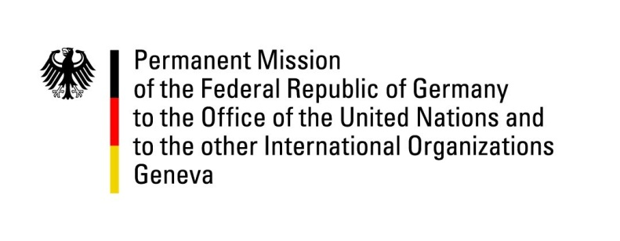

United Nations Human Rights Council

31st Session of the UPR Working Group

Geneva, 7 November 2018

Recommendations and advance questions to
Mauritius

Mr. President,

Germany welcomes the delegation of Mauritius to the UPR and commends Mauritius for its efforts to align with international human rights standards, reflected particularly by the work in the context of the “Human Rights Action Plan.”

However, we remain concerned about ongoing reports of corporal punishment as well as abuse and sexual exploitation of children, a topic that has not been tackled appropriately in the “Human Rights Action Plan”.

Germany recommends Mauritius to:
- Ratify the 1951 Convention relating to the Status of Refugees and the 1967 Protocol relating to the Status of Refugees;
- Ratify the second Optional Protocol to the International Covenant on Civil and Political Rights, aiming at the abolition of the death penalty;
- Adopt the consolidated Children’s Bill, including a prohibition of all forms of corporal punishment of children in all settings;
- Ensure that its domestic legislation relating to sexual exploitation of children meets international standards, and provide adequate access to recovery and reintegration measures to child victims of sexual abuse.

Thank you, Mr. President

