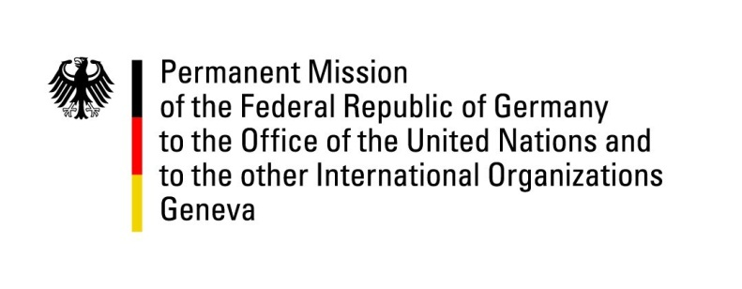

United Nations Human Rights Council

31st Session of the UPR Working Group

Geneva, 07 November 2018

Recommendations and advance questions to
Mexico

Thank you, Mr. President,

Germany welcomes the delegation of Mexico and commends it for adopting the general law on torture and the law on enforced disappearances and appreciates the efforts made to improve the human rights situation.
Germany remains concerned about the high level of impunity and the deteriorating situation regarding enforced disappearances, attacks against journalists and human rights defenders.

Germany recommends:
1) Conduct prompt, thorough, independent and impartial investigations into attacks against journalists and human rights defenders and ensure that any perpetrator of such violent attacks be brought to justice in a fair trial; ensure that the Mexican Federation’s Protection Mechanism for Journalists and Human Rights Defenders receives long-term funding and political support;
2) Fully implement on a nationwide basis the Federal Law against enforced Disappearances and ensure, as part of its implementation, the creation of an efficient judicial mechanism involving federal, state and municipal institutions that ensures prompt, thorough, independent and impartial investigations, a fair trial, and convictions against any perpetrator of enforced disappearances;
3) Enter into a structured cooperation with the international community on the Rule of Law, particularly with the aim to enhance Mexican institutions’ capabilities and determination to conduct prompt, thorough, independent and impartial investigations, to ensure fair trials, and to attain convictions based on international standards.
Thank you, Mr. President.

