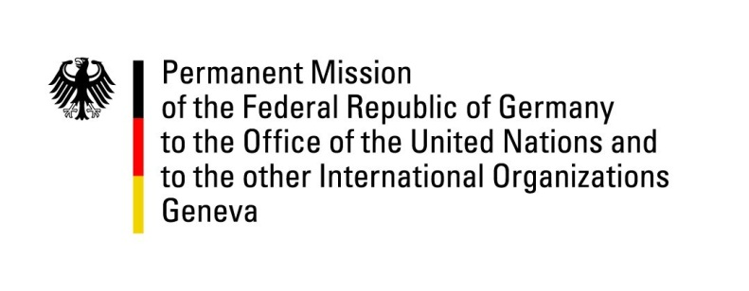

United Nations Human Rights Council

31st Session of the UPR Working Group

Geneva, 06 November 2018

Recommendations and advance questions to
Nigeria

UPR Statement Nigeria:

Germany commends the efforts made by the Nigerian Government to investigate the abuses allegedly committed by security forces, and welcomes the conduction of Boko Haram trials.
Germany remains concerned about human rights deficits persisting, including those with regard to detention conditions and the high number of death sentences still being imposed.

Germany would like to offer the following recommendations:

- Strengthen political and institutional safeguards in order to ensure free and fair elections and call upon all parties and the Security Forces to refrain from violence and intimidations and accept the results declared by the Independent National Election Commission;

- Publish the reports about abuses committed by Security Forces and to implement the recommendations, including the prosecution of those responsible for violence committed against civilians;

- Ensure that enforced disappearance constitutes a crime in line with Nigeria’s obligations under the Convention for the Protection of All Persons from Enforced Disappearance and to allow independent international and regional human rights investigators full access to investigate allegations concerning enforced disappearances and extrajudicial executions;

- Repeal the existing Same-Sex Marriage Prohibition Act of 2013 and ensure that nobody is punished because of sexual orientation and to release all individuals held in detention because of homosexuality;

- Strengthen the Child’s Rights Act from 2003 by expanding it to all 36 states and thus contribute to end trafficking, sexual abuse, forced marriages and economic exploitation of children in Nigeria.

GERMAN ADVANCE QUESTIONS TO NIGERIA:
- Germany commends the Government of Nigeria on recent efforts to investigate the allegations of Human Rights abuses by Security Forces, such as the Commission of Inquiry regarding the Special Anti-Robbery Squad (SARS, est. Aug 2018), Presidential Investigative Panel to review compliance of the Armed Forces with Human Rights’ obligations and rules of Engagement (est. August 2017), the Judicial Commission of Inquiry concerning the clashes between Armed Forces and the Islamic Movement of Nigeria in Zaria in Dec. 2015 (est. in 2016). Which measures are taken in the follow-up of the investigations? Will there be prosecutions of those accused of military violence? Will there be amendments to the military rules of engagement? Will the report of SARS-inquiry and the Presidential Investigative Panel be made public?

- How will the Government of Nigeria ensure that suspects in the Boko Haram trials are granted a fair trial and that standards of rule of law are upheld?

- With regard to the Nigerian general elections in February 2019, what kind of preparations is the government taking to ensure free, fair, credible and peaceful elections, and to prevent violence and intimidations by state and security agencies in the context of the electoral process?

