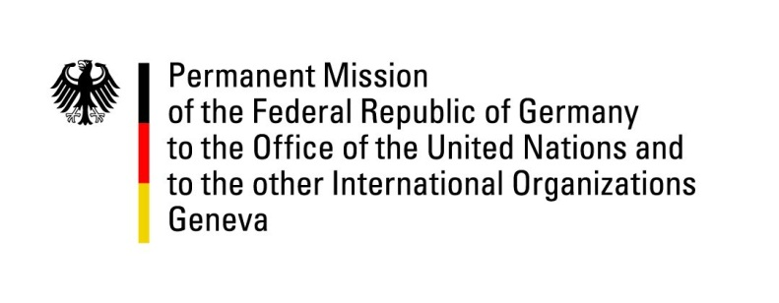

United Nations Human Rights Council

31st Session of the UPR Working Group

Geneva, 05 November 2018

Recommendations and advance questions to
Senegal

Thank you, Mr. President,

Germany welcomes the delegation of Senegal and commends it for the progress made with regard to modernization of Quran schools and their inclusion into the official education system. We also welcome the sensitization campaigns to reduce child marriages.

Germany recommends:
- to conduct regular and effective inspections of all public schools, including religious schools, to ensure that national standards concerning the content and quality of education, infrastructures and fair treatment are met.

- to remove from the Family code any provisions that allow for the discrimination of women in law or in practice, including Article 152 assigning marital authority to the husband, and Article 277 assigning paternal authority to the father.

- to adopt the Children’s Code aiming at putting the protection of children’s rights in conformity with international and regional child rights obligations and thus avoid discrimination between children or parents on the basis of gender.

- to make sensitization on women’s rights and gender equality an essential part of school curricula, starting from primary education.

Thank you, Mr. President.

GERMAN ADVANCE QUESTIONS TO SENEGAL:
- When will the announced law aiming at the protection of children against for example child labor and child marriage will be adopted and through which measures does the government plan to secure effective implementation of the law?
- How many persons have been arrested since 2013 on the basis of Article 319 of the penal code and how many of them have been convicted?

