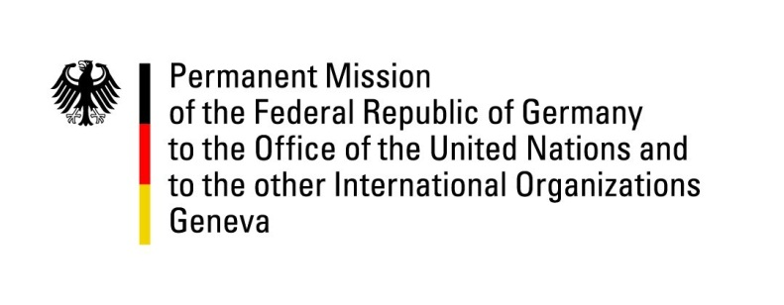

United Nations Human Rights Council

31st Session of the UPR Working Group

Geneva, 5 November 2018

Recommendations and advance questions to
Saudi Arabia

Mr. President,
Germany welcomes the delegation of Saudi Arabia and appreciates the strengthening of women’s rights and steps taken to reform the system of guardianship. However, we remain seriously concerned about violations of freedom of expression, the continued application of the death penalty and recent arrests of human rights defenders. We are deeply concerned by the fate of Jamal Khashoggi and call upon Saudi Arabia to provide a complete and detailed response in this regard.
Germany recommends:

1. Forego or at least restrict the application of the death penalty to the most serious crimes committed.
2. Immediately release all Human Right Defenders, in particular women.
3. Bring national legislation in line with international human rights standards with regards to freedom of expression and freedom of the press and protect journalists and human rights defenders from intimidation, threats and arbitrary arrests.
4. Continue to reform the male guardianship system to reduce the areas in which men and women are legally treated differently.
5. Take all feasible additional measures to protect civilians in Yemen and ensure unimpeded humanitarian and commercial access to Yemen.
6. Cooperate fully with UN human rights mechanisms including by issuing a standing invitation to HRC special procedures mandate holders.
Thank you, Mr. President

ADVANCE QUESTIONS TO SAUDI ARABIA

- In the 2nd UPR cycle Saudi Arabia supported a recommendation to adopt an NGO law which should take into account the views of civil society stakeholders and provide an enabling framework for the development of civil society in Saudi Arabia. In 2015 Saudi Arabia approved a NGO law. Why is there no category for human rights NGOs foreseen in this law?
- What are Saudi Arabia’s steps towards gender equality particularly to strengthen the participation of women in the economic and business life?
- Will Saudi Arabia take steps to abolish travel restrictions for women that stem from the system of male guardianship?

