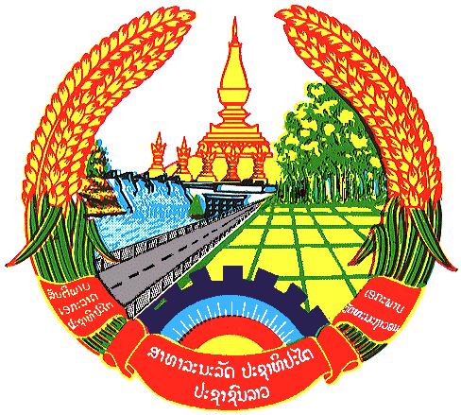

Statement by the delegation of the Lao PDR
At the 30th Session of UPR Working Group
Geneva, 7 – 18 May 2018

Review of Djibouti: 10 May 2018, at 14:30 - 18:00 hours

Mr. President,
My delegation welcomes the Delegation of the Djibouti to the 30th Session of the UPR Working Group and would like to thank for their comprehensive presentation of the National Report on human rights.

The Lao PDR commends the government of Djibouti for ratifying majority of the international and regional human rights conventions and for its efforts to implement recommendations accepted in the last UPR. We also congratulate its establishment of the long-term national strategy also known as Djibouti Vision 2035 which laid a foundation to promote and protect human rights in the country.

In conclusion, The Lao PDR wish to make following recommendations:

- Continue to assist and raise awareness about human rights among all genders and
- Continue to implement the Bill on the promotion and protection of the rights of the persons with disabilities.

We wish Djibouti all the success in its Third Cycle of UPR.

I thank you, Mr. President.

