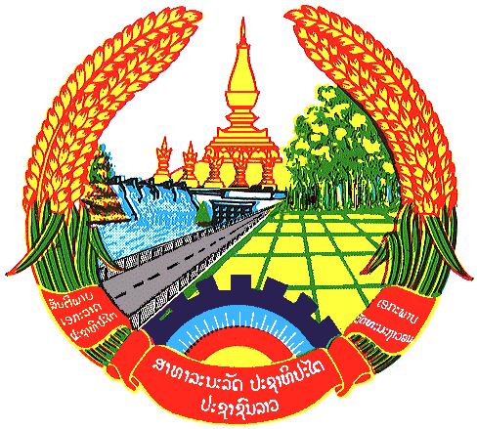

Statement by the delegation of the Lao PDR
At the 30th Session of UPR Working Group
Geneva, 7-18 May 2018

Review of Azerbaijan: 15 May 2018, at 09:00 - 12:30 hours

Mr. President,
My delegation welcomes the Delegation of the Azerbaijan to the 30th UPR and would like to thank for its National Report.

The Lao PDR commends the achievement taken by the Government of Azerbaijan for its encouraging efforts to the establishment of the Women’s Association for Rational Development to strengthen the role of women in social development.

The Lao PDR has 3 recommendations as follow:

- Continue assistance and promotion on women’s empowerment both public and private sectors.
- Continue to take systematic and coherent measures to raise awareness of and combat discrimination against women.
- Continue to promote and protect the rights of persons with disabilities.

We wish Azerbaijan all the success in its Third Cycle of UPR.

I thank you, Mr. President.

