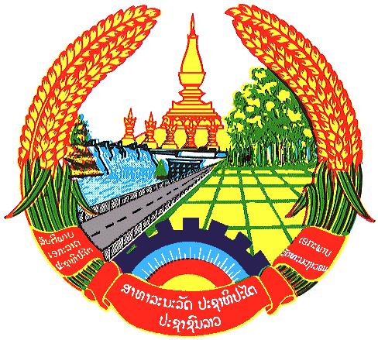

**Statement by the delegation of the Lao PDR**

**At the 30th Session of UPR Working Group**

**Geneva, 7 – 18 May 2018**

Review of Uzbekistan: 9 May 2018, at 09:00 - 12:30 hours

Mr. President,

My delegation welcomes the Delegation of the Uzbekistan to the 30th Session of the UPR Working Group and would like to thank for their comprehensive presentation of the National Report on human rights.

The Lao PDR commends measures taken by the Government of Uzbekistan to implement the previous UPR recommendations and congratulates its efforts to implement the National Action Strategy on Five Priority Areas of the Country’s Development for the state and society. Particularly in the social development area such as strengthening social protection and health protection of citizens as well as to support the socially vulnerable group of person with disabilities. In addition, we welcome of the progress of the bill on guarantees of equal rights and opportunities for women and men.

The Lao PDR would like to make following recommendations:

* Continue to improve of the support system for persons with disabilities and to strengthen of their rights and freedoms, and
* Continue to assist and promote the advancement of women in the society.

We wish Uzbekistan every success in its Third Cycle of UPR.

I thank you, Mr. President.