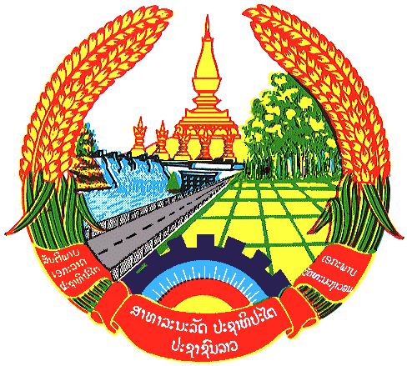

Statement by the delegation of the Lao PDR
At the 30th Session of UPR Working Group
Geneva, 7 – 18 May 2018

Review of Colombia: 10 May 2018, at 09:00 - 12:30 hours

Mr. President,
My delegation welcomes the Delegation of the Colombia to the 30th Session of the UPR Working Group and express appreciation for their extensive presentation of the National Report on human rights.

The Lao PDR commends measures taken by the Government of Colombia to implement the previous UPR recommendations and congratulates its commitment to develop its 20 years of National Strategy for Guaranteeing Human Rights from 2014-2034 as it set a good base to protect and promote Human Rights in the country. We also would like to further extending our congratulations for their adoption of the National Public Policy on Gender for Women and the Comprehensive Plan to Guarantee Women a Life Free from Violence.

In conclusion, my delegation wishes to make two following recommendations:

- Continue assistance and promotion on women’s empowerment both public and private sectors and
- Continue to tackle sexual violence against women to ensure protection of women’s rights.

We wish Colombia all the success in its Third Cycle of UPR.

I thank you, Mr. President.

