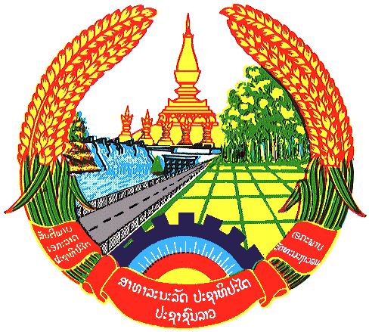

Statement by the delegation of the Lao PDR
At the 30th Session of UPR Working Group
Geneva, 7-18 May 2018

Review of Turkmenistan: 7 May 2018, at 09:00 - 12:30 hours

Mr. President,
The Lao PDR welcomes the Delegation of the Turkmenistan to the 30th Session of the UPR Working Group and would like to thank for an extensive presentation of the National Report on human rights.

The Lao PDR commends measures taken by the Government of the Turkmenistan to implement the previous UPR recommendations and congratulates its adoption of the National Plan on Gender Equality in which emphasizes the state guarantees of equal rights for women and the National Action Plan on Human Rights which is to support implementation employment policies and strategies. In Addition to the Right of high education and dynamism for women.

The Lao PDR would like to make following recommendations:

- Continue promoting women’s rights to ensure that they are fully respected.
- Continue assistance and promotion on women’s empowerment both public and private sectors.

We wish Turkmenistan every success in its Third Cycle of UPR.

I thank you, Mr. President.

