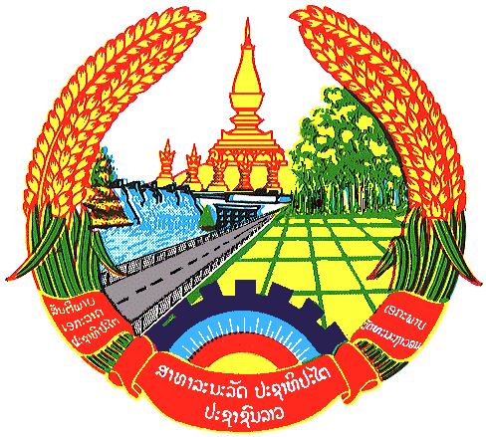

Statement by Mr Bovonethat Douangchak
Counsellor and Deputy Permanent Representative
Permanent Mission of the Lao PDR
At the 30th Session of UPR Working Group
Geneva, 7-18 May 2018

Review of Russia Federation: 14 May 2018, at 14:30 - 18:00 hours

Mr. President,
My delegation warmly welcomes the Distinguish Delegation of the Russia Federation to the 30th Session of the UPR Working Group and would like to thank for its comprehensive National Report.

The Lao PDR commends measures taken by the Government of Russia Federation for its tireless efforts to establish Commissioner for Children’s Rights by appointing specialists to court case to ensure the protection of children. We also wish to extend our congratulation for the adoption of the public policy for the protection of children which was signed by the President of Russian and declared as the decade for children.

To conclude, The Lao PDR would like to make following recommendations:

- Continue to provide necessary support and opportunity for children to enjoy their human rights and
- Continue to assist and promote the employment of persons with disabilities.

We wish Russia every success in its Third Cycle of UPR.

I thank you, Mr. President.

